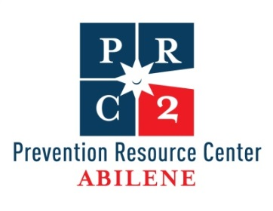
Regional Drug Trends

Consumption Indicator | State | Region 2
Binge Alcohol Use in the Past Month | 23.62% | 22.37%
Alcohol Use in the Past Month 12 or Older | 48.51% | 43.9%
Alcohol Use in the Past Month among Persons Aged 12 to 20 | 23.23% | 24.83%
Binge Alcohol Use in the Past Month among Persons Aged 12 to 20 | 14.81% | 18.07%
Alcohol Dependence in the Past Year among Persons Aged 12 or Older | 2.97% | 3.06%
Alcohol Dependence or Abuse in the Past Year among Persons Aged 12 or Older | 6.53% | 6.63%
Dependence or Abuse of Illicit Drugs or Alcohol in the Past Year among Persons Aged 12 or Older | 7.9% | 8.14%
Illicit Drug Use in the Past Month among Persons Aged 12 or Older | 7.11% | 6.52%
Illicit Drug Use Other than Marijuana in the Past Month among Persons Aged 12 or Older | 3.09% | 3.03%
Cocaine Use in the Past Year among Persons Aged 12 or Older | 1.47% | 1.25%
Nonmedical Use of Pain Relievers in the Past Year among Persons Aged 12 or Older | 4.45% | 4.47%
Illicit Drug Dependence in the Past Year among Persons Aged 12 or Older | 1.58% | 1.41%
Illicit Drug Dependence or Abuse in the Past Year among Persons Aged 12 or Older | 2.41% | 2.29%
Needing But Not Receiving Treatment for Illicit Drug Use in the Past Year among Persons Aged 12 or Older | 2.22% | 2.05%
Marijuana Use in the Past Month among Persons Aged 12 or Older | 5.25% | 5.11%
First Use of Marijuana among Persons Aged 12 or Older | 1.73% | 1.33%
Marijuana Use in the Past Year among Persons Aged 12 or Older | 9.39% | 8.23%
Perceptions of Great Risk of Smoking Marijuana Once a Month among Persons Aged 12 or Older | 37.65% | 40.29%
Region 2 Counties include: Taylor, Clay, Montague, Archer, Jack, Young, Throckmorton, Stephens, Shackelford, Eastland, Callahan, Comanche, Brown, Coleman, Runnels, Wilbarger, Foard, Cottle, Baylor, Knox, Hardeman, Haskell, Stonewall, Kent, Jones, Fisher, Scurry, Wichita, Nolan, and Mitchell
From the National Survey on Drug Use and Health

